|  |  |
| --- | --- |
| Railway Neighbour | 151-153 St Vincent Street  Glasgow  G2 5NW |
| **16 November 2018**  Ref: **Network Rail works in Blackford** |

Dear Neighbour

During the last two weeks, Network Rail contractors have begun establishing their work sites in Blackford to deliver two distinct pieces of work. Both projects will enable the delivery of a new rail freight facility being developed by Highland Spring to the north-east of Blackford.

The Network Rail projects consist of:

* **1. The construction of a new footbridge and connecting footpath to replace Panholes pedestrian level crossing**
* **2. The re-instatement of a railway connection into the site of the railway yard in Blackford.**

Both projects are expected to be delivered by 31 March 2019.

1. **New footbridge**

Following planning approval from Perth and Kinross Council, a new pedestrian footbridge will be built approximately 200m to the west of Panholes pedestrian level crossing, which will close once the new footbridge is completed.

The closure is required in order to remove the risks posed by the level crossing. With faster, quieter, electrified trains using the line in the near future, the risks of retaining a foot crossing in this location will only increase. The removal of the crossing is also required to help facilitate the development of the freight facility. As a result of additional train movements on the railway in that vicinity, the risk to pedestrians using Panholes level crossing would have increased.

The new bridge will offer stepped access only, a design considered appropriate for the un-pathed rural routes that it connects. The design of the bridge is low maintenance, compliant with Network Rail’s rigorous safety standards and offers good underfoot grip, meaning that it is well suited for this location.

The existing path will be re-routed to tie in with the new bridge.

While the majority of our works will take place during dayshifts (07:00hrs to 18:00hrs), some of our bridge delivery works require us to access the railway when trains are not running. This may require some nightshift working (23:00hrs to 08:00hrs).

Some of the equipment we use, in particular heavy plant and machinery, means that some noise is unavoidable but we will do all we can to minimise it. We have also asked those working on site to work with consideration for the local community.

Works to the footbridge and new footpath will take place from now until late January 2019. **A temporary pedestrian diversion route will be in place** during the works and will be required until the freight yard connection works are completed by 31 March 2019.

**New footbridge location:**



1. **Freight Yard Connection Works**

To allow Highland Spring to deliver their new rail freight facility, Network Rail will be reconnecting the former freight site to the north-east of Blackford to the railway.

This work, which will be delivered on railway land using Network Rail’s permitted development rights, involves the installation of a new stretch of rail, and additional railway components.

Work will take place from **now until 31 March 2019**. …

Unfortunately, the on-track nature of this work means that **we need to carry out a lot of our work at weekends or overnight**. Network Rail is legally obliged to work on the railway at times that cause least disruption to trains. This is also a safer method of working.

We understand that this will cause disturbance to some residents. We apologise in advance for any disruption and we will do everything we can to keep this to a minimum.

**Freight Yard site compound marked below in red:**

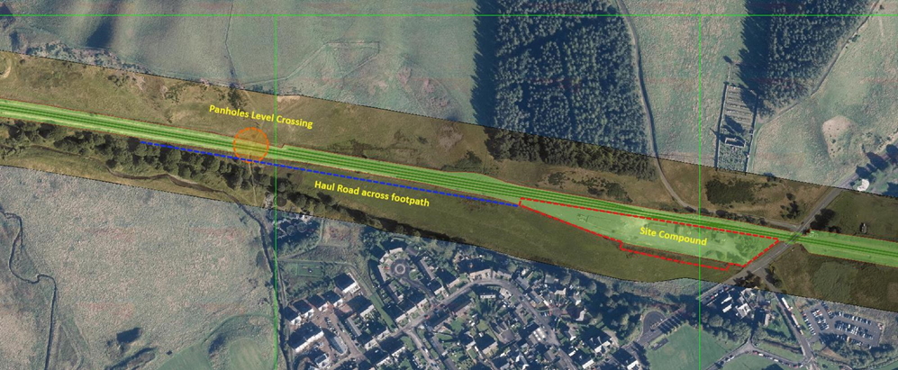

Network Rail’s contractors on both projects are committed to delivering these works to the highest possible standards. Sub-contractors and suppliers have been advised to respect the residential nature of Blackford and action will be taken should those standards fall below the standards expected. Drivers have been instructed to follow set routes through the village and a speed advisory sign has been installed to encourage drivers to keep their speed limited to 20mph.

I do hope our work doesn’t disturb you too much but if you have any questions or concerns, **please do not enter the work site**, which can be a dangerous environment without the correct protective equipment. All queries should be directed to our **24-hr helpline on 03457 11 41 41** or you contact us via our website: [www.networkrail.co.uk/contactus](http://www.networkrail.co.uk/contactus)

Yours sincerely,

Craig Bowman

Senior Communications Manager

Network Rail