|  |
| --- |
| **Blackford South Connection** |
| Temporary Closure of Panholes Level Crossing  15 November 2018 |
|  |

Contents

1. Introduction 1

2. Panholes Level Crossing Closure & Temporary Diversion 2

2.1 Current Core Path 2

2.2 Diversion Route 2

2.3 Signage during Construction 3

3. Compound Locations 4

3.1 Blackford Compound 4

3.2 Panholes Compound 5

4. Vehicle Routes 6

4.1 Vehicle Movements 6

5. Programme 7

5.1 Blackford South Connection Key Dates 7

5.2 Footpath Closure Map 7

1. Introduction

Panholes pedestrian level crossing is part of the Core Path network. The level crossing is being closed for safety reasons during the construction of a new railway connection to the proposed Highland Spring freight terminal. These railway connection works are being carried out by Network Rail’s permitted development rights under Class 29 of the Town and Country Planning (General Permitted Development) (Scotland) Order 1992 (as amended).

This footpath management plan concerns the temporary closure of Panholes Level Crossing only and temporary diversion of the walking route. The current path from Moray Street leading to the railway will remain open up to the closure point.

The route across the railway will be permanently diverted across a new footbridge approximately 200m to the west of the level crossing site when all works are complete by 31st March 2019; and subject to confirmation of the Stopping Up Order.

1. Panholes Level Crossing Closure & Temporary Diversion
   1. Current Core Path



Figure 1 Existing Core path network with position of level crossing circled

The existing core path network is indicated by the purple dotted line and Panholes Level crossing is indicated by the red circle.

* 1. Diversion Route

During the construction period from 19th November 2018 to 31st March 2019 the crossing will be closed and the diversion will be along Moray Street and over Blackford Level Crossing. The route of the formal diversion, from the start of the path at Moray Street over Blackford level crossing and along the core path back to the other side of Panholes Level crossing is an additional distance of approximately 800m.

The existing path leading to Panholes Level Crossing will remain open and access will still be possible over the field adjacent to the work site, although it should be noted that this is not within Network Rail ownership and therefore access cannot be confirmed. The map below indicates the diversion route in red.



Figure 2 Diversion route marked in red

* 1. Signage during Construction

Signage locations are proposed as follows:

* North of Blackford Level Crossing at entrance to field footpath
* South end of BLFD/3, Moray Street adjacent to the Danny Burn
* Moray Street at Moray Place
* Moray Street at Abercairney Place
* Abercairney Place at entrance to access to play area
* BLFD/111 at Milton of Panholes, Panholes Road (U188)
* North end of BLFD/3 at Panholes Road (U188)

The signs will read:

|  |
| --- |
| No access across the railway line at Panholes Level Crossing from Monday 19th November 2018 until Sunday 31st March 2019 for track works.  Diversion via Blackford Level Crossing (Public Road). |

Figure 3 Proposed Temporary Closure Signage

1. Compound Locations
   1. Blackford Compound

The site compound for the railway connection works, and for works to construct a footbridge to the west of Panholes Level Crossing, at Blackford is located within the former railway yard adjacent to Blackford Level Crossing, Figure 4. The site will provide parking for 40 vehicles and a walking route within the compound will separate pedestrians and vehicles.

A haul road extending approximately 500 m from the end of the former yard will be constructed to allow the construction of an extended railway embankment in the location of the new south connection infrastructure. This is indicated in Figure 5.

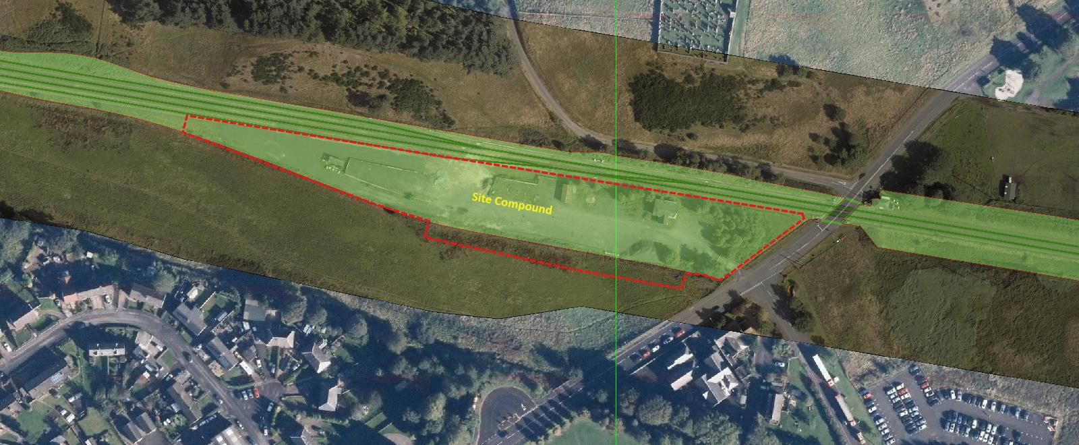

Figure 4 Blackford South Connection site compound

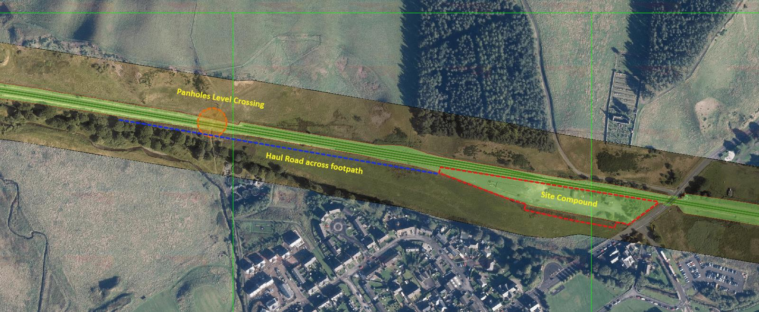

Figure 5 Haul road indicated in blue

* 1. Panholes Compound

An additional site compound for the construction of the new footbridge will be located on the north side of the railway and is indicated in the plan below.

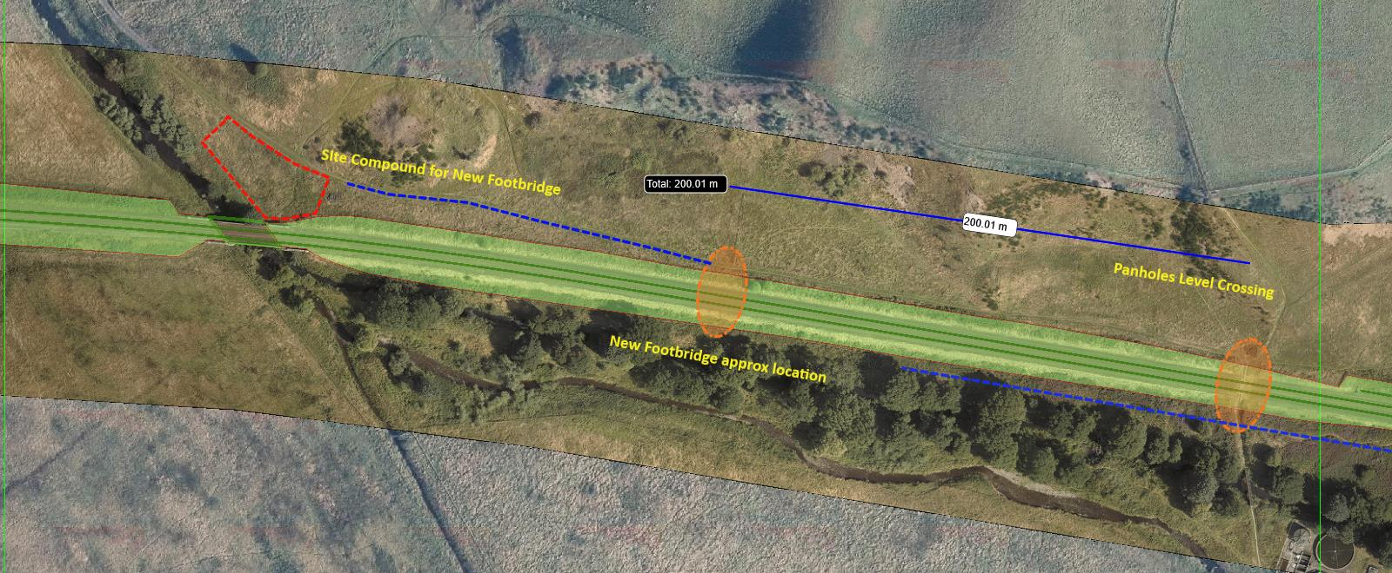

Figure 6 Panholes Footbridge Compound indicated in red

1. Vehicle Routes
   1. Vehicle Movements

A traffic management plan is in place for all vehicle movements in and out of the site compound and restricts all contractors’ vehicles to 20mph through the village. The proximity of Blackford Primary School is recognised and deliveries will be pre-arranged and managed. All vehicles from the South will enter the village from the A9 via Moray Street and all liveried vehicles are restricted to 20mph to align with the Highland Spring arrangements. On leaving the site compound all vehicles will turn left and not return to the A9 via Moray Street.

Construction plant will move over the haul road as necessary during the construction period and the site will be fenced off from the adjacent open field to separate pedestrians and moving vehicles and construction plant. As work progresses to initially create the site compound and haul road the fenced location may of necessity be altered and the work extended towards Panholes Level Crossing. On completion the entire site will be fenced to secure materials, plant and equipment and to separate pedestrians from the constructed works.

1. Programme
   1. Blackford South Connection Key Dates

Key Dates

|  |  |
| --- | --- |
|  |  |
| Vegetation clearance | 20th – 23rd October |
| Creation of Site Compound | 20th – 27th October |
| Construction of Haul Road | 1st November – 13th December |
| Embankment Construction | 12th November – 31st December |
|  |  |

* 1. Footpath Closure Map

See below.

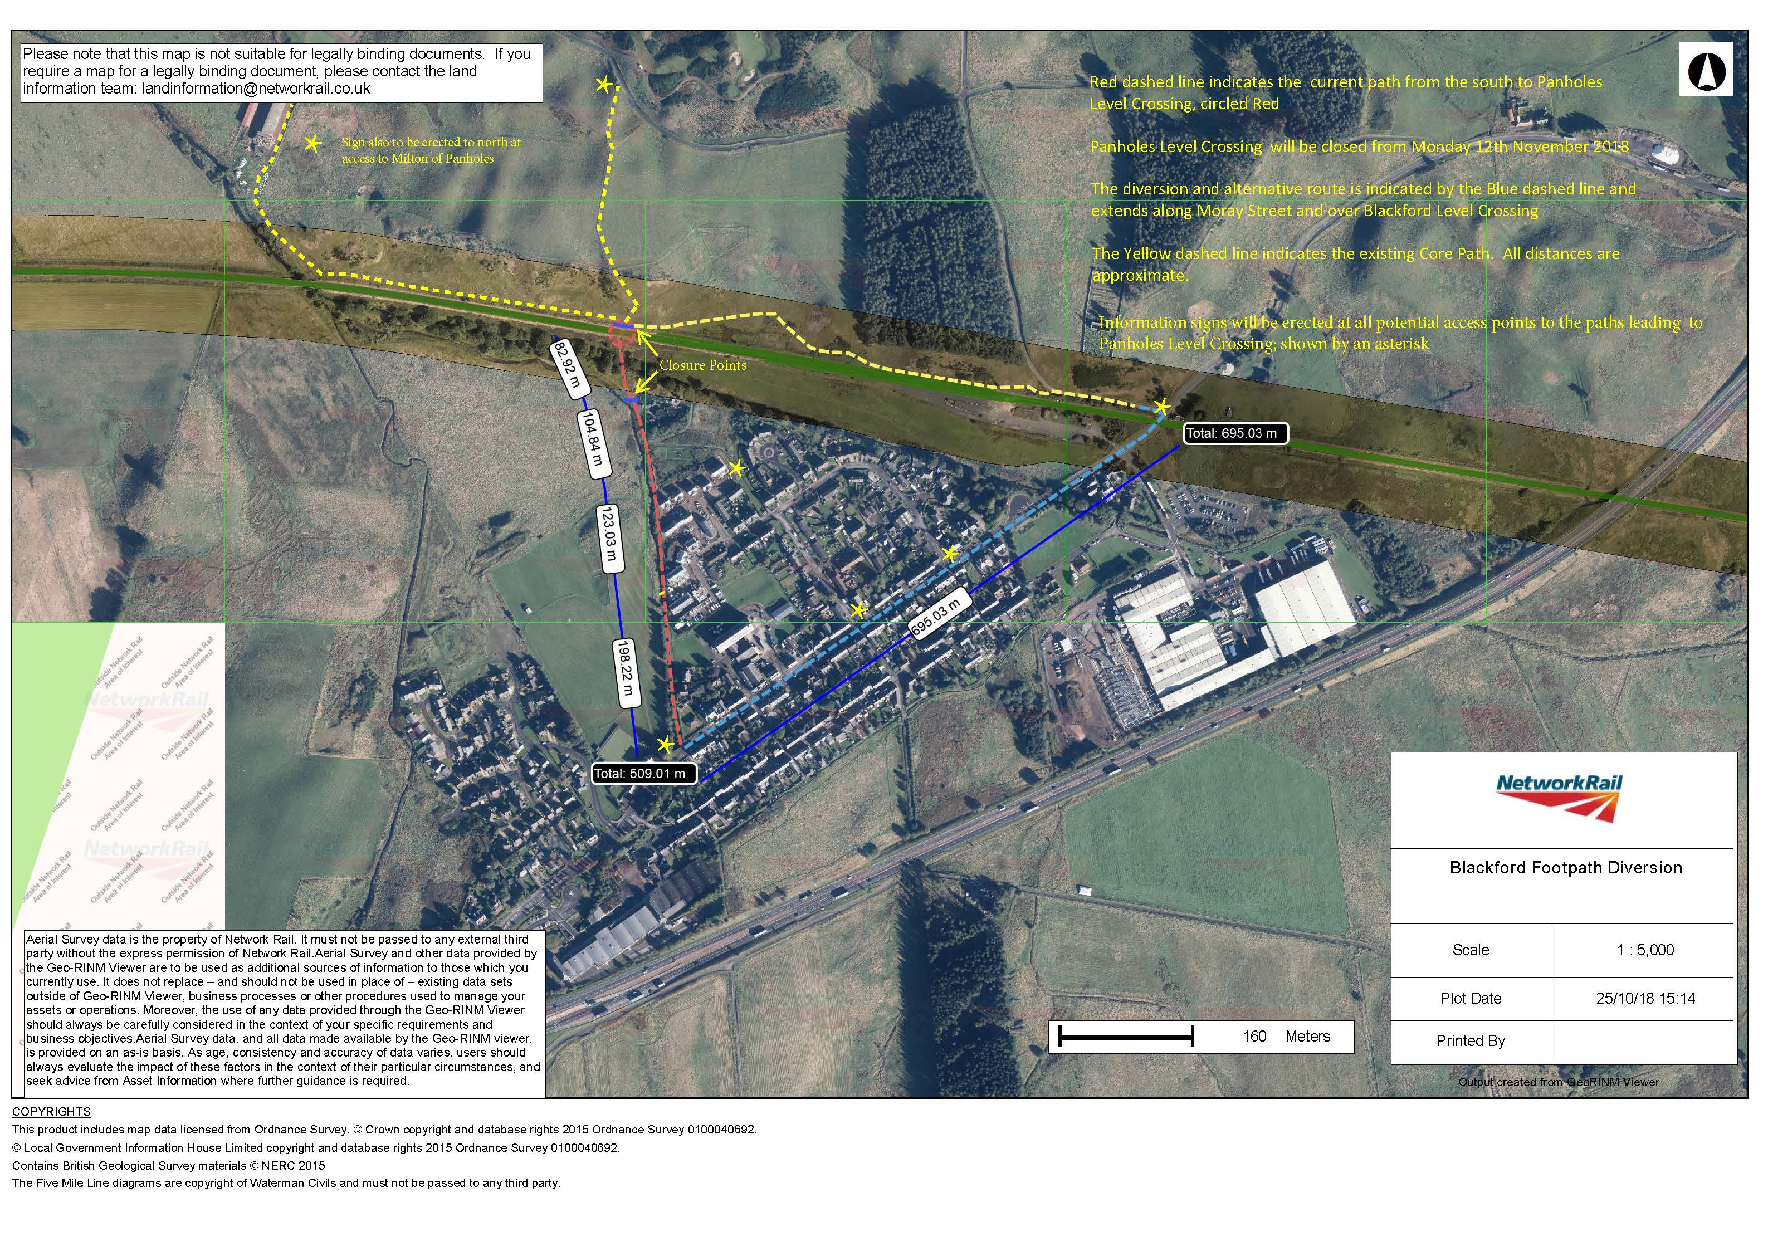

|  |
| --- |
| Network Rail Infrastructure Projects  Scotland & North East  Buchanan House, 58 Port Dundas Road Glasgow G4 0LQ T +44(0)141 555 4900  www.networkrail.co.uk  This document is the property of Network Rail Infrastructure Limited. It shall not be reproduced in whole or part nor disclosed to a third party without the written permission of Network Rail Infrastructure Limited. Uncontrolled copy once printed from its electronic source. Published and Issued by Network Rail Infrastructure Limited, Kings Place, 90 York Way, London N1 9AG Copyright 2018 Network Rail Infrastructure Limited. All rights reserved. |