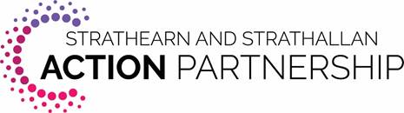

Blackford Community Council has received £1,000 which is available for projects in the Blackford area.

Groups are invited to apply to the Community Council for funding.

Closing date for applications is 17th April 2020.

The project(s) should address one or more of the following priority areas:

Social isolation and Loneliness
Access to social opportunities and wider service provision for vulnerable people
Inter-generational activities
Connectivity
Access to digital connections and IT support
Access to transport
Services for Children and Young People
Access to services children and young people
Children and young people’s influence on issues important to them
Community volunteering opportunities
Community Capacity and Empowerment
Access to and use of public buildings and community space
Community ownership or management of assets
Community events and other social activities
Understanding and knowledge of community issues and aspirations
Skills and confidence within communities
Quality of Life
Support and services to improve mental health and wellbeing
Support for carers
Low income/ access to employment
Supporting families during holiday periods
Access to social and leisure activities
Barriers to employment and education
Support and advice around welfare
1. You will spend all of the agreed funding by 31st March 2021.
2. If any part of the agreed funding set out above is unspent on 31st March 2021, all unspent money MUST be returned to Blackford Community Council.
3. Original receipts as proof of expenditure must be provided.
For an application form, contact Blackford Community Council at enquiries@blackfordcommunitycouncil.org.uk
or contact the Treasurer, Irene McLaughlan, on 01764 682495.

